“Lab” report

# Schematic

# 

# Layout

# 

# DRC/LVS report

# 

# Measurement (RC extracted test circuit)

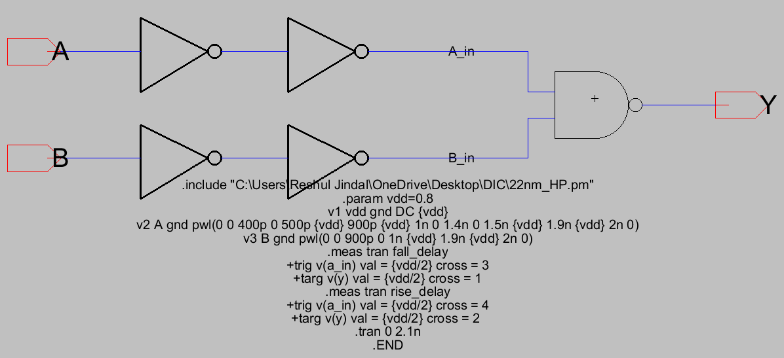

Waveforms and results

